Cabrillo College Student-Athlete Concussion Policy

Developed by the Sports Medicine staff at Cabrillo College

The Cabrillo College Sports Medicine staff, made up of team physicians, certified athletic trainers and athletic training students is committed to treating potentially catastrophic brain injury in the safest manner. Our concussion policy and concussion management protocol have been developed and derived from the most recent literature on sport-related concussion.

The CC Sports Medicine staff will utilize a three-fold approach when determining an athlete’s readiness to return to play following a concussion. In the event that the CC Sports Medicine staff suspects that an athlete has sustained a concussion, the concussion management protocol requires the evaluation of the athlete’s symptoms, neurocognitive function, and balance which will provide the sports medicine staff the necessary information to return the athlete to play safely. The findings of these post-injury assessments are then compared to pre-season baseline assessments. Pre-season baseline assessments are conducted through the Sway Medical App which utilizes symptoms, balance, reaction time, impulse control, inspection time, and immediate and delayed recall as tests to create a baseline score individually for each athlete. The Sway app is a concussion evaluation software that is used as a tool by many healthcare providers to provide the best quality care to their patients. When a potential concussion occurs, the Sway Medical App can be used to test the athletes neurocognitive and balance scores against their own self to determine any impairment. This allows quantifiable data for determining if someone should be placed in the concussion protocol as well as collecting symptoms for subjective data assessment. This app is also used during the protocol to determine if an athlete is ready to return to play following the concussion protocol. They must test back to their baseline levels before progressing through the final steps of the return to play protocol, ensuring that they are as safe as possible upon return to their sport.

The following concussion policy and concussion management protocol has been adopted by CC Sports Medicine and is to be followed by all teams for managing athletes suspected of sustaining a concussion. All athletes will be baseline tested before they are allowed to compete for a sports team and all will sign the following documents acknowledging the concussion facts and need to report symptoms.

Cabrillo College Concussion Policy
1) All CC student-athletes must read the NCAA Concussion Fact Sheet and sign the attached student athlete statement acknowledging that:
a) They have read and understand the NCAA Concussion Fact Sheet
b) They accept the responsibility for reporting their injuries and illnesses to the institutional medical staff, including signs and symptoms of concussions.
2) All CC coaches (head coaches and assistant coaches) must read and sign the attached coaches statement acknowledging that they:
a) Have read and understand the NCAA Concussion Fact Sheet
b) Will encourage their athletes to report any suspected injuries and illnesses to the institutional medical staff, including signs and symptoms of concussions; and that they accept the responsibility of referring any athlete to the medical staff suspected of sustaining a concussion.
c) Have read and understand the CC Concussion Management Protocol

3) All CC team physicians, athletic trainers, and athletic training students, must sign the attached medical provider statement acknowledging that they:
a) Will provide athletes with the NCAA Concussion Fact Sheet and encourage their athletes to report any suspected injuries and illnesses to the institutional medical staff, including signs and symptoms of concussions.
b) Have read, understand, and will follow the CC Concussion Management Protocol

4) The Managers of Athletic Training will coordinate the distribution, educational session, signing, and collection of the necessary documents. The signed documents will be kept in the student-athlete’s medical file which is kept in the main athletic training room.

5) The Director of Athletics and the Managers of Athletic Training will coordinate the signing of the aforementioned documents on an annual basis for the medical personnel and coaches. The signed documents, along with the established CC Concussion Policy will be kept on file in the main athletic training room. A copy of the CC Concussion Policy will also be distributed to every coach, athletic trainer, and athletic training students at the beginning of every school during the athletic department in-service day, which is held at the end of every August.
6) The Director of Sports Medicine will coordinate an annual meeting to review and update the Concussion Policy with the medical staff. Any changes made to the policy will go into effect on August 1 of that year.

CC Concussion Management Protocol

A concussion occurs when there is a direct or indirect trauma to the brain. As a result, momentary impairment of mental functions such as memory, balance/equilibrium, and vision may occur. It is important to recognize that many sport-related concussions do not result in loss of consciousness and, therefore, all suspected head injuries should be taken seriously. Coaches and fellow teammates can be helpful in identifying those who may potentially have a concussion, because a concussed athlete may not be aware of their condition or potentially be trying to hide the injury to stay in the game or practice.

- Concussion management begins with pre-season baseline testing. Every student-athlete must receive a pre-season baseline assessment for concussion utilizing the Sway Medical App.

- An athlete suspected of sustaining a concussion will be evaluated by the team’s athletic trainer using a general signs and symptoms concussion evaluation, a symptom checklist, and the Sway App. Should the team physician not be present, the athletic trainer will notify the team physician ASAP to develop an evaluation and treatment plan. Ideally, an assessment of symptoms will be performed at the time of the injury and then serially thereafter (i.e. 2-3 hours post injury, 24 hours, 48 hours, etc.). The SCAT 6 is an alternative test that will be used when the Sway app is not available.

3) Any student-athlete with a suspected concussion shall not return to activity for the remainder of that day. Medical clearance will be determined by the team physician or combination of team physician and athletic trainers involved with management of the concussion.
a. Student-athletes that sustain a concussion outside of their sport will be managed in the same manner as those sustained during sport activity.

4) Student-athletes may begin the return to play (RTP) protocol once their symptoms have reduced to mild or absent. They may progress through the first 3 stages of the protocol with mild symptoms that do not increase more than 1-2 points on a symptom scale of 0-6 during exercise. Stages 4-6 must be symptom free and the athlete must score within 10% of their baseline test using Sway in order to return to their sport. If an athlete regresses (symptoms return or they are unable to pass their baseline test) they will be asked to stay on that stage of the protocol until symptoms improve or they are able to test at baseline scores. If they are at stage 5 or 6 (contact practice or games) they will be asked to return to stage 4 (non-contact practicing).

Zurich Exertional Return to Play Protocol

This exertional protocol allows a gradual increase in volume and intensity during the return to play process. The athlete is monitored for any concussion-like signs/symptoms during and after each exertional activity.
The CC Concussion Policy will use the Zurich return to play guidelines to return athletes to participation after being diagnosed with a concussion.

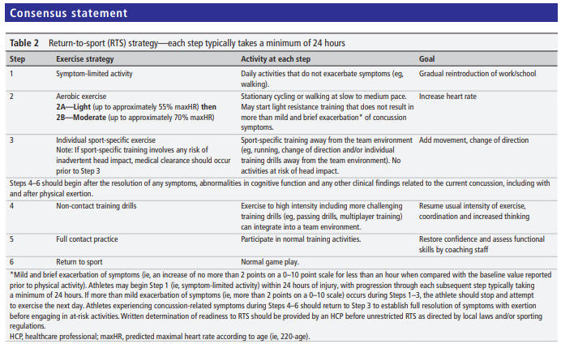

No athlete can return to full activity or participation in practice or competitions until they are asymptomatic and cleared by the team physician.

Cabrillo College Concussion Policy Acknowledgment Statement

For Student-Athletes

All CC student-athletes must read the NCAA Concussion Fact Sheet and sign this student athlete statement acknowledging that:
a) I have read and understand the NCAA Concussion Fact Sheet
b) I accept the responsibility for reporting my injuries and illnesses to the institutional medical staff, including signs and symptoms of concussions.

Print Name: _______________________________________________________

Student-Athlete Signature: _____________________________________________________

For Coaches

All CC coaches (head coaches and assistant coaches) must read and sign this coaches statement acknowledging that they:
a) Have read and understand the NCAA Concussion Fact Sheet
b) Will encourage their athletes to report any suspected injuries and illnesses to the institutional medical staff, including signs and symptoms of concussions; and that they accept the responsibility of referring any athlete to the medical staff suspected of sustaining a concussion.
c) Have read and understand the CC Concussion Management Protocol

Print Name: _______________________________________________________

Coaches Signature: _______________________________________________________

For Sports Medicine Staff

All CC team physicians, athletic trainers, and athletic training students, must sign this medical provider statement acknowledging that they:
a) Will provide athletes with the NCAA Concussion Fact Sheet and encourage their athletes to report any suspected injuries and illnesses to the institutional medical staff, including signs and symptoms of concussions.
b) Have read, understand, and will follow the CC Concussion Management Protocol

Print Name: _______________________________________________________

Sports Medicine Staff Signature: _______________________________________________________

